**CHPT3**   
**Creative Brief**   
              

**Project Name: Size Guide**                                                                **Date: Feb 2021** 

**Project Owner: David Millar**                                                  **Project Priority: High** 

**Background:** 

Since 2015 CHPT3 has been a licensing brand with little control in sourcing and development of the products it sold beyond aesthetics. Our sportswear products were made by the Italian cycling brand Castelli.

The 2021 we are rebooting the brand and will launch our own products that we have designed, developed and manufactured. This is a big change for the business model because we are no longer making our money as a retailer, we are now a manufacturer. It is also a big change for the customers. We are introducing women's wear for the first, we are introducing products for dirt (gravel and mountain bike) and we are introducing a new range of life style wear that is made in UK. All of our products will be sustainable and many of them made of recyclable materials. Finally, we are making our products last longer in both style and performance. It will be the finest cyclewear you can buy, it will be premium prices and customers will expect the best of the best.

We want CHPT3 to be industry-leading in its story-telling, product-design, and delivery-experience. Everything must feel better, be different, try harder - while never losing its ability to be playful.

For all of these reasons it is key that we don’t disappoint customers when they shop with us. They should be guided to the perfect fit and they should feel that they made the right choice.

Our primary business is apparel/soft goods - both sportswear and sports inspired lifestyle wear.

Our market is UK, Northern Europe, Indonesia, South Korea, Malaysia, the progressive cities in US. Our customers are mostly leisure cyclist that want the best for themselves and want to be elegant and playful at the same time. The age group is mostly people +30 that invest in premium quality. They want to look and feel fast, but what really matters is comfort when they go for a 5-hour ride in rain, wind, cold and heat.

**Problem:**

We want your brains and coding skills to help us solve one problem:

*HOW DO WE GUIDE OUR CUSTOMERS TO FIND THEIR SIZE?*

CHPT3 is an e-comm business.

We are investing heavily in brand awareness and will increase traffic dramatically

We want people to find it easy to purchase from us.

We don’t want people returning what they’ve purchased.

We want people to think that we are the best in the industry at finding their fit.

Our conversion rate is low from landing on site to buying.

We have too many returns due to apparel being the wrong size.

In May 2021 we launch our own product range for men and women with a new size grading system that will be unfamiliar to past, present and future customers, yet consistent across our entire apparel range because of our own manufacturing.

We want an elegant, simple, playful way to find your size. The goal is not to speed up the process of purchasing but to make it more interesting and personal. It should feel like having your clothes tailored to you. The experience should be: I am finding *my*cycling apparel not *some*cycling apparel. The goal is also to reduce returns dramatically, we want customers to be happy with what they end up getting, not disappointed.

Most brands have a sizing chart where you have to measure yourself and then find the best fit on the chart. That is buying *some*clothes. We want a digital experience that guides you to your fit by asking questions that you can relate to and that feels personal. Our digital experience should feel like buying *my*clothes.

**Solutions**

Ultimately, we envision a kind of pop-up API that helps you find your fit for every product in three simple clicks. It should end up telling the user what size we recommend. The API should be customized to each product category because finding your fit works out differently for shorts, jerseys and sweatshirts.

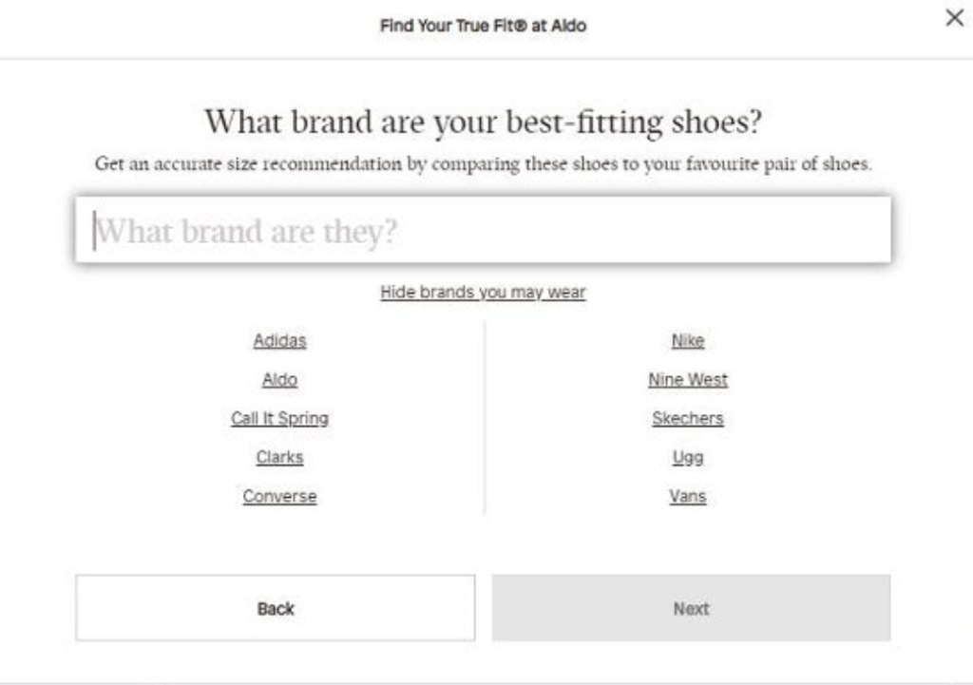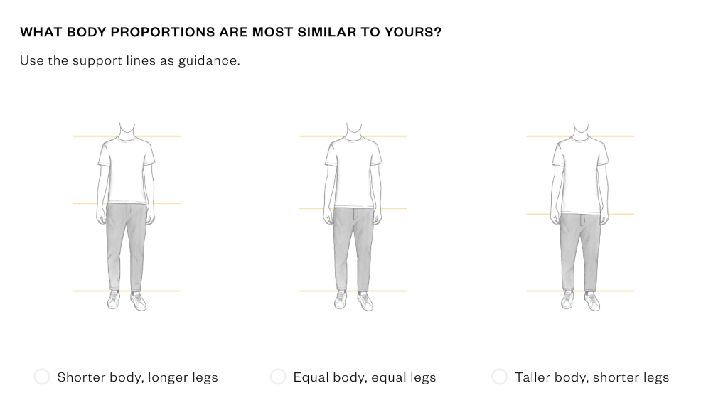

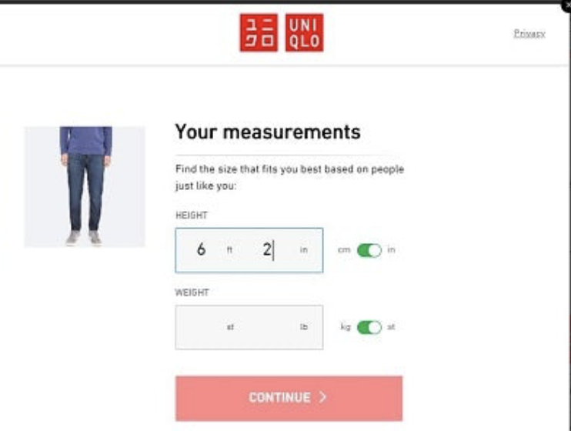

We expect three deliverables from the project:

1. A logic for how CHPT3 translates *your*body shape into the right CHPT3 fit. Could be through a funnel process – first find a baseline fit, then correct this on a personal preference – shape, age, preferred comfort, other brands you now. The logic should be built on research on CHPT3 sizes, data on average sizes compared to CHPT3 products, data on CHPT3 sizing versus competing brands, data on CHPT3 sizing versus other comparisons (like your t shirt, trousers or other sports products.
2. Build an algorithm that calculates the optimal fit with given inputs. For starters it is fine that the algorithm is static, but would be interesting to get your ideas on how it can learn as more customers use the system.
3. Build an API that works with Shopify and a UX that is elegant and playful. We should be able to test the API in a beta.

Some of the specs that are important:

* The solution needs to work for cycling shorts, cycling jerseys, base layers, vests/jackets. If you feel it is achievable it would be great also to have the solution work for lifestyle wear – t-shirt, sweatshirt, hoodie
* The solution should work for both men and women, but the algorithm will probably we different for men and women because their bodies are very different.
* You can use any kind of comparison or input that you think will work – body measurements, shape images, other brands, existing garderobe, culture (where you are from) or something we haven't even thought about yet.
* The solution should be built on our sizing for the 2021 products and the grading charts that you will get for every product category/gender.
* The solution should be easy to use and hopefully without the use of a measurement tape.
* The UX should be in line with our brand, it should feel familiar to our customers and not like a foreign element – you will get a brand guide you can use to find the right colour, typeface, design
* It should be easy to decode the product hierarchy:
* When using the solution is it clear what product category, we are finding your personal fit to?
* Does it feel human and does it talk like a personal tailor would?
* Is it elegant and delightful, does it make you smile?
* The user should be able to find their size easily:
* How do we create as few steps as possible from landing on site to buying with confidence?
* The solution should be built on data we have or can get now and not data that come with use. It will be great if you can build in machine learning that makes the solution better over time.
* It will be great to get your advice on navigation – how users find the solution
* It will be great to get your advice on how the metrics/size can be saved for users for next time – without breaking GPDR rules. Could be a solution for members/account holders. Could be data that is stored on the mobile and not shared with us or others.

**Objectives:** 

Create an industry leading size guide that eliminates abandoned checkouts and customer returns while creating a customer journey that is elegant and playful.

**Target Audience** 

Men and women of all ages. 

**Targets** 

* Increase our conversion rate
* Reduce abandoned checkouts
* Eliminate returns due to wrong sizing
* Be used as an example of how to do it

**Tone of Voice/Brand Vision:** 

We want it to be highly efficient and logical yet playful at the same time and although consistent in tech constantly learning and adapting so that customers actually enjoy using it. 

**Delivery:**

Research: Feb

Logic: End Feb

Algorithm: March

Beta: March/April

Delivery: May

**How we work together:**

CHPT3 will pay for costs involved in the project, please tell us upfront what you need.

The project is run as a special project, which means a lot of creativity and a lot of attention from David and Mikkel.

We suggest a weekly check in

We will provide you with grade charts for all products and put you in touch with our product developer Sam and our product designer

You will get the intellectual property to the solution and can use CHPT3 as a case for your work